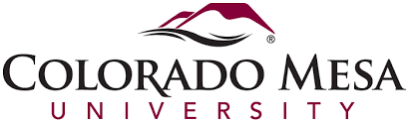
Media Day 2017 Registration Form
We are the Public Relations Club at CMU, and this year we are organizing Media Day. Please help us plan accordingly by completing the form below. Return by Friday, February 17th via mail or email.

Adviser Name ________________________________________
Name and type of student media you advise ______________________________
School _______________________________________
Phone Number_________________________________
Email ________________________________________
# of Students Attending __________________________________

This year we are planning an awards luncheon, and will be assessing a $5 fee per student to help with the cost of lunch and materials.

______ We plan to pay the $5.00 per student fee at registration on March 6th.
______ Please bill our school.

Please email your completed registration form to Professor Megan Fromm at mfromm@coloradomesa.edu

Or send to:
Prof. Megan Fromm
Mass Communication
1100 North Ave. Grand Junction, CO 81501

Your students can also submit work to be judged in advance for our writing, photography and design contests. An email containing more information will be sent out soon.
President Ciera Colson cjcolson@mavs.coloradomesa.edu
Vice President Alexis Dymek asdymek@mavs.coloradomesa.edu
Secretary Siena Shupe smshupe@mavs.coloradomesa.edu

